**Project Development Phase**

**Sprint - 1**

|  |  |
| --- | --- |
| **Team ID** | **PNT2022TMID19193** |
| **Team Members Name** | **Danush P S,Praveen Babu R, Shalinisri J, Kavipriyaa P** |

**views.py**

*from* django.shortcuts *import* render  
  
*from* .models *import* Stock  
  
  
*def* home(request):  
 *if* request.user.is_authenticated:  
 *try*:  
 Latest_Added_Stock = Stock.objects.order_by(' Recently_Updated')[0]  
 *except*:  
 Latest_Added_Stock = *None  
 if* Latest_Added_Stock *is None*:  
 *return* render(request, 'Inventory_Management_For_Retailers/home.html', dict())  
 *else*:  
 *return* render(request, 'Inventory_Management_For_Retailers/home.html', {'Last_Stock': Latest_Added_Stock})  
 *return* render(request, 'Inventory_Management_For_Retailers/home.html', dict())

**models.py**

*from* django.db *import* models  
  
  
*class* Stock(models.Model):  
 Product_Name = models.CharField(max_length=100)  
 Recently_Updated = models.DateTimeField('date Updated')  
 Date_Added = models.DateTimeField('date Added')  
 No_of_stocks = models.IntegerField(default=0)  
 Price = models.DecimalField(  
 max_digits=10,  
 decimal_places=2,  
 default=0)  
 Tax = models.DecimalField(  
 max_digits=5,  
 decimal_places=2,  
 default=0)  
  
 *def* __str__(*self*) -> str:  
 *return self*.Product_Name + " - No of Stocks " + str(*self*.No_of_stocks)

**TEMPLATES**

**home.html**

<!DOCTYPE *html*>  
<html *lang*="en">  
  
<head>  
 <meta *charset*="UTF-8">  
 <link *href*="https://cdn.jsdelivr.net/npm/bootstrap@5.1.3/dist/css/bootstrap.min.css" *rel*="stylesheet" *integrity*="sha384-1BmE4kWBq78iYhFldvKuhfTAU6auU8tT94WrHftjDbrCEXSU1oBoqyl2QvZ6jIW3"  
 *crossorigin*="anonymous">  
 {% *load* static %}  
 <link *href*="{% *static* 'oursite/home.css' %}" *rel*="stylesheet"*}*>  
 <script *src*="https://cdn.jsdelivr.net/npm/bootstrap@5.1.3/dist/js/bootstrap.bundle.min.js" *integrity*="sha384-ka7Sk0Gln4gmtz2MlQnikT1wXgYsOg+OMhuP+IlRH9sENBO0LRn5q+8nbTov4+1p"  
 *crossorigin*="anonymous">  
 </script>  
 <meta *http-equiv*="X-UA-Compatible" *content*="IE=edge">  
 <meta *name*="viewport" *content*="width=device-width, initial-scale=1.0">  
 <title>Document</title>  
</head>  
<body>  
 <nav *class*="navbar navbar-expand-lg navbar-dark bg-dark">  
 <a *class*="navbar-brand" *href*="#">GST System</a>  
 <button *class*="navbar-toggler" *type*="button" *data-toggle*="collapse" *data-target*="#navbarText" *aria-controls*="navbarText" *aria-expanded*="false" *aria-label*="Toggle navigation">  
 <span *class*="navbar-toggler-icon"></span>  
 </button>  
 <div *class*="collapse navbar-collapse" *id*="navbarSupportedContent">  
 <ul *class*="navbar-nav mr-auto">  
 <a *href*="{% *url* 'Inventory_Management_For_Retailers:home' %}" *class*="nav-link active"><li *class*="nav-item">Home</li></a>  
 {%*if* user.is_authenticated%}  
 <a *href*="#" *class*="nav-link"><li *class*="nav-item">Hello, {{user.first_name }}</li></a>  
 <a *href*="#" *class*="nav-link"><li *class*="nav-item">Logout</li></a>  
 {%*else*%}  
 <a *href*="#" *class*="nav-link"><li *class*="nav-item">Login</li></a>  
 <a *href*="#" *class*="nav-link"><li *class*="nav-item">Register</li></a>  
 <a *href*="/admin" *class*="nav-link">Admin</a>  
 {%*endif*%}  
 <a *href*="#" *class*="nav-link disabled"><li *class*="nav-item">Help</li></a>  
 </ul>  
 </div>  
 </nav>  
 </body>  
</html>

**Running the Django Server**

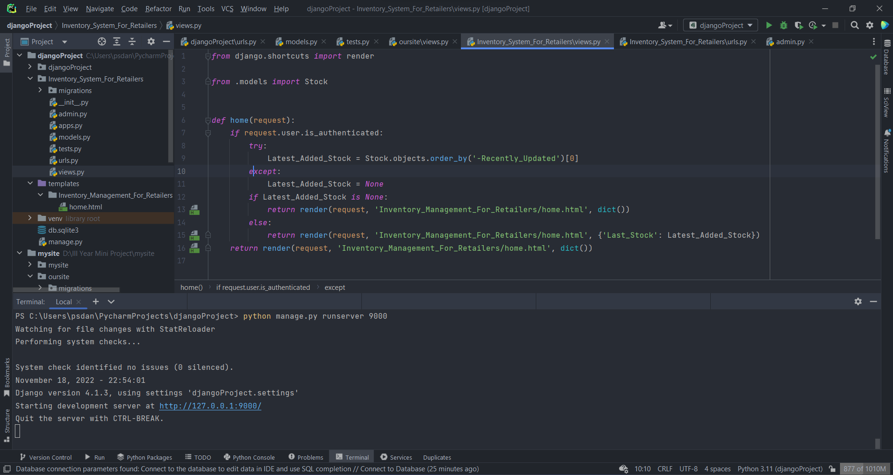

**OUTPUT:**

